**Project Summary: ANN Model for House Value Prediction**

**1. Introduction** This project involves developing a simple Artificial Neural Network (ANN) model to predict house values based on given input features. The model is trained using historical data, and its weights are saved for future use. Furthermore, a Streamlit application is developed and deployed on Hugging Face to enable interactive predictions.

Data info:

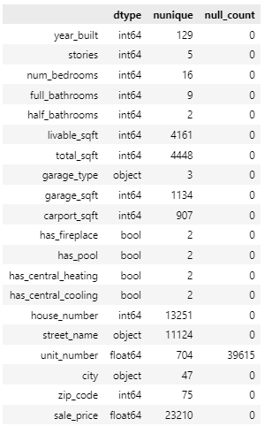

**2. Data Preprocessing** The dataset is processed before training the model. Key steps in data preprocessing include:

* Handling missing values
* Normalizing numerical features
* Encoding categorical variables
* Splitting the data into training and testing sets

**Dataset Link:** [House Value Estimation Dataset](https://www.kaggle.com/datasets/deepak007chaubey/housevalueestimation)

**3. Model Development** A simple ANN model is built using PyTorch. The architecture consists of:

* An input layer corresponding to the number of features in the dataset
* One or more hidden layers with activation functions
* An output layer predicting the house value

**4. Model Training and Weight Saving** The model is defined using the PyTorch torch.nn module and trained using an optimizer such as Adam. Training is performed using the training dataset, and evaluation metrics such as Mean Squared Error (MSE) are monitored. Once trained, the model’s weights are saved using torch.save() for later use.

**5. Streamlit Application** A Streamlit application is developed to allow users to input house-related data and get predictions in real-time. The app workflow includes:

* Loading the saved model weights using torch.load()
* Accepting user inputs for house features
* Preprocessing inputs similarly to the training phase
* Making predictions and displaying results

**6. Deployment on Hugging Face** The Streamlit app is packaged and deployed on Hugging Face for accessibility. Deployment steps include:

* Creating a Hugging Face Space
* Uploading the necessary files (model weights, Streamlit script, and dependencies)
* Configuring the application to run seamlessly

**App Link:** [House Price Prediction App](https://huggingface.co/spaces/kanneboinakumar/House-Price-Prediction)

**7. Conclusion** This project successfully implements an ANN model for house value prediction using PyTorch, integrates it into a user-friendly Streamlit app, and deploys it on Hugging Face for public access. The model’s performance can be further improved by experimenting with different architectures, hyperparameters, and additional data sources.